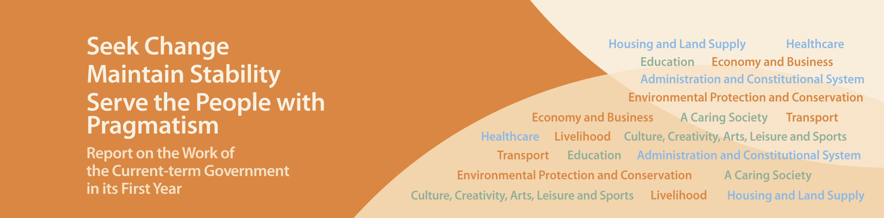
Economy and Business

- Gross Domestic Product (GDP) grew by 2.8% in real terms year-on-year in the first quarter of 2013. Total employment reached a new high of 3,735,500 persons in March to May 2013. The seasonally adjusted unemployment rate remained low at 3.4%. The Comprehensive Social Security Assistance caseload dropped to 266,510 in May 2013, the lowest in the past 10 years.
- Strengthened Hong Kong’s role as an offshore Renmimbi (RMB) business hub and its status as an international financial centre by serving as a platform for enterprises and financial institutions all over the world to carry out various financial activities such as RMB payments, financing and investments. At end-April 2013, Hong Kong had the world’s largest offshore pool of RMB funds, with total RMB deposits and outstanding RMB certificates of deposits amounting to RMB837 billion. RMB trade settlement conducted through Hong Kong banks in the first four months of 2013 exceeded RMB1,100 billion – a year-on-year increase of 48%.
- Launched RMB Qualified Foreign Institutional Investors (RQFII) A-share ETF in July 2012. At mid-June 2013, the market value of assets managed under the five listed A-share ETFs reached RMB35.8 billion. Since March 2013, the Mainland authorities have allowed more financial institutions to apply for RQFII status and relaxed the restrictions on the investment of RQFII funds, thus facilitating the further development of off-shore RMB business with more market participants and more RMB products in Hong Kong.
- Launched the CNH Hong Kong Interbank Offered Rate fixing (CNH HIBOR fixing) in June 2013, which provides a reliable benchmark for the pricing of loan facilities and is conducive to the further growth of the offshore RMB loan market.
- Implemented the first phase of the Basel III capital standards from January 2013 and the relevant disclosure requirements for banks’ capital adequacy in June to strengthen the resilience of banks gainst risks and align with the international standards, thus contributing to the stability of the banking system.
- Expanded the size of the Government Bond Programme from $100 billion to $200 billion, and launched a further issuance of the inflation-linked retail bond (iBond) up to HK$10 billion in June 2013.
- Extended the application period of the special concessionary measures under the SME Financing Guarantee Scheme to February 2014 to continue helping the trade obtain loans in the commercial lending market. Over the past year, more than 6,800 approved applications have received loan guarantees totalling nearly $24 billion.
- Established the Financial Services Development Council in January 2013 to engage the industry and formulate proposals to promote the further development of Hong Kong's financial services industry and map out the strategic direction for development.
- The Central People’s Government acceded to HKSAR Government’s request to establish the CEPA Joint Working Group to assist Hong Kong businesses and professionals to make full and better use of CEPA. At the first meeting held in June 2013, the Working Group explored concrete measures to resolve specific policy and regulatory issues encountered by the trade in using CEPA to enter the Guangdong market.
- Obtained support from the Central People’s Government for “early and pilot” implementation of more CEPA measures in Guangdong and other provinces/regions in the Pan-Pearl River Delta, in order to open up markets for Hong Kong enterprises.
- Strengthened co-operation with cities in the Pearl River Delta Region and actively explored opportunities for mutually beneficial development with Nansha and Qianhai.
- Launched the plan to enhance the functions of all four Mainland Offices of the HKSAR Government to better assist Hong Kong residents and enterprises in the Mainland and started preparations for the establishment of a fifth Mainland Office in Wuhan next year. We are also exploring the feasibility of setting up more liaison units in various Mainland cities.
- Established the high-level Economic Development Commission (EDC) in January 2013, underpinned by four Working Groups on transportation; convention and exhibition industries and tourism; manufacturing industries, innovative technology, and cultural and creative industries; and professional services. The Government will seek specific recommendations from the EDC on the formulation of industrial policy, and the overall strategy and policy for broadening the economic base of Hong Kong and enhancing economic development.
- Strengthened economic and trade co-operation with emerging markets. Signed a Free Trade Agreement (FTA) with Chile in September 2012, and secured the agreement of ASEAN in April 2013 to pursue a bilateral FTA.
- Commenced provisions in the Competition Ordinance relating to the Competition Commission in January 2013. We are preparing for full implementation of the Ordinance.
- Announced in February 2013 the way forward for the development of the patent system in Hong Kong, including the introduction of the “original grant” patent system.
- Commenced the Trade Descriptions (Unfair Trade Practices) (Amendment) Ordinance 2012 with effect from July 2013.
- Promoted economic, trade and financial co-operation between Hong Kong and the United States. In June 2013, the Chief Executive, the Hong Kong Trade Development Council, other organisations and more than 200 delegates visited the United States to encourage the United States business and financial sectors to use Hong Kong for economic, trade and financial activities with Mainland China and Asia.
- The internationally renowned Hague Conference on Private International Law (The Hague Conference) established its Asia Pacific Regional Office in Hong Kong in late 2012. This has enhanced Hong Kong's position as a regional hub for international legal services.
- The Hong Kong Arbitration Centre of the China International Economic and Trade Arbitration Commission (CIETAC), the first arbitration centre set up by CIETAC outside the Mainland, was inaugurated in September 2012. This has reinforced Hong Kong's status as a centre for international arbitration.
- Implemented the Employee Choice Arrangement for the Mandatory Provident Fund (MPF) Schemes since November 2012, which provides about 2.3 million employees greater autonomy in selecting MPF trustees and schemes, enhances market competition and creates room for fee reduction.
- Launched in June 2013 a five-year assistance scheme costing $230 million to help 4,300 hawkers enhance the fire safety standards and design of their hawker stalls.
- Banned trawling activities in Hong Kong waters since December 2012 to promote the long-term well being of our fisheries industry. In January 2013, we introduced a $500 million fund to subsidise programmes and research conducive to sustainable fisheries development. In June 2013, we announced details relating to the partial lifting of the moratorium on marine fish culture licences.

