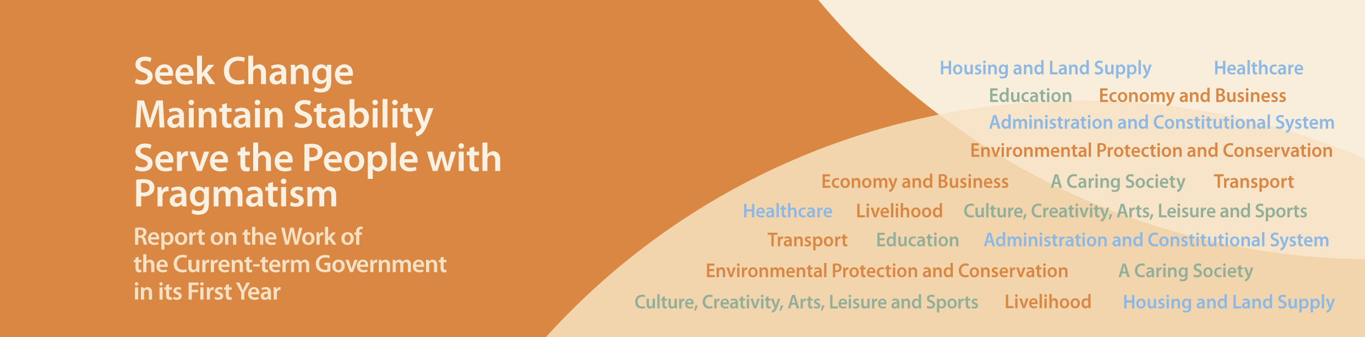
A Caring Society

- Launched in April 2013 the Old Age Living Allowance to provide $2,200 per month to eligible elderly persons. It is estimated that more than 400,000 elderly persons will benefit in 2013-14.
- Extended the Public Transport Fare Concession Scheme for the Elderly and Eligible Persons with Disabilities to buses and ferries in August 2012 and March 2013 respectively to enable these groups to travel for the concessionary fare of $2 per trip. The daily average passenger trips using MTR, buses and ferries under the Scheme is around 660,000, while estimated expenditure is around $600 million in 2013-14.
- Reconstituted the Commission on Poverty in December 2012, decided to formulate for the first time a poverty line, and discussed poverty alleviation measures at great length. Six Task Forces were established to explore issues including education, employment and training; special needs groups; social security and retirement protection; and, societal engagement.
- To introduce the Guangdong Scheme no later than November 2013 to enable eligible elderly people who choose to reside in Guangdong to apply for the Old Age Allowance without having to return to Hong Kong each year. The estimated expenditure is $395 million per annum.
- To launch the first phase of the Pilot Scheme on Community Care Service Voucher for the Elderly in September 2013 in eight districts with an allocation of $380 million from the Lotteries Fund. By adopting the “money follows the user” approach, elderly people can choose the community care services that suit their individual care needs. At least 1,200 elderly persons will benefit from the scheme.
- Increased the subvention of 7,000 residential care places with continuum of care and upgraded the remaining 7,850 ordinary residential care places in subvented residential care homes for the elderly to places with continuum of care, with an additional recurrent funding of $164 million. Elderly residents can receive better services as a result.
- To provide about 1,200 additional subsidised residential care places and 320 day care places for the elderly from now to 2015-16.
- Seeking approval from the Legislative Council (LegCo) in June 2013 to allocate an additional $200 million to extend the service duration of the Short-term Food Assistance Service and increase the allocation provided to the operators with effect from October 2013.
- Announced in January 2013 the regularisation of the “Home Care Service for Persons with Severe Disabilities” from March 2014, and extension of the service to all districts to cover persons with severe disabilities who are living in the community regardless of whether they are on the waiting lists for subvented residential care places. The estimated annual recurrent expenditure is $203 million, which will benefit 3,250 persons with severe disabilities.
- Regularised the “Transitional Care and Support Centre for Tetraplegic Patients” service since March 2013. The estimated annual recurrent expenditure is $10.8 million, and 130 persons with severe physical disabilities will benefit.
- Increased the manpower of residential care homes and day training centres for persons with disabilities in 2013-14 to meet the needs of ageing service users. The estimated annual recurrent expenditure is $67.9 million.
- Increased the manpower of the Integrated Community Centres for Mental Wellness (ICCMWs) in 2013-14 to dovetail with Hospital Authority’s Case Management Programme. The total annual allocation for ICCMWs amounts to more than $190 million.
- Set up the Standard Working Hours Committee in April 2013 to promote informed and in-depth public discussion of the working hours policy in order to build consensus and assist the Government in identifying the way forward.
- To introduce a bill into LegCo in the 2013-14 legislative session to provide for three days of paid paternity leave to implement the family-friendly policy.
- Increased the Statutory Minimum Wage to $30 with effect from May 2013, benefiting some 210,000 low-paid employees (based on 2012 statistics), which helps alleviate working poverty.
- Introduced the enhancement measures of the Work Incentive Transport Subsidy Scheme with effect from the claim month of January 2013, providing the option of individual application as an alternative to household application and relaxing the income and asset limits in parallel.
- Abolished the levy imposed on employers of foreign domestic helpers (FDHs) with effect from August 2013 to ease the burden on about 250,000 families employing FDHs, and proposed an injection of $15 billion into the Employees Retraining Board to provide the Board with long-term support.
- Engaged a consultancy team in May 2013 to study how to improve the retirement protection system in Hong Kong.
- Injected an additional $15 billion into the Community Care Fund to continue to plug the gaps in the existing system and strengthen poverty alleviation efforts.
- To establish the $500 million Social Innovation and Entrepreneurship Development Fund within this year.
- Set up an additional support service centre for ethnic minorities (EMs) and two sub-centres in December 2012 to facilitate EMs’ early integration into the community. Introduced two additional radio programmes broadcast in Hindi and Thai in March 2013 to enhance EMs’ understanding of Hong Kong.
- Reconstituted the Steering Committee on Population Policy in December 2012 and brought in non-official members. The Steering Committee is preparing to consult the public on a host of issues relating to population policy in September this year.

