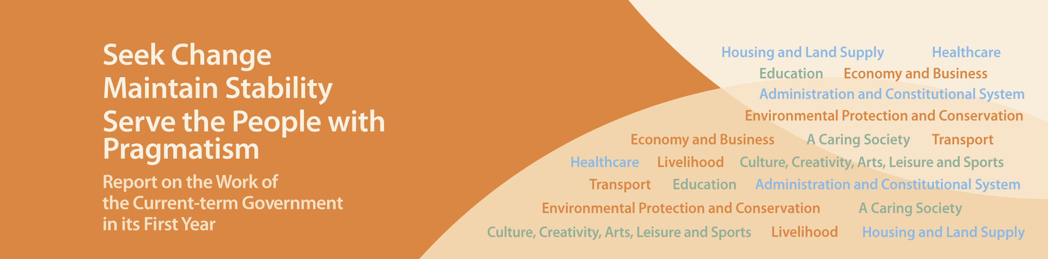
Housing and Land Supply

- Announced in October 2012 the enhancement to the Special Stamp Duty and the introduction of the Buyer’s Stamp Duty. Announced in February 2013 the doubling of ad valorem stamp duty for residential and non-residential properties and advancing the charging of ad valorem stamp duty on non-residential property transactions. These measures have been effective in combating speculative activities and preventing further escalation in housing prices.
- Abolished the Application Mechanism since 2013-14, thereby resuming the lead in land sales. We plan to put up all the residential sites in the 2013-14 Land Sale Programme for sale in order to increase housing land supply to the largest extent.
- Put forward 10 measures in January 2013 to increase the supply of housing land in the short to medium term. Based on what is currently known, if seven of the measures are implemented, more than 300 hectares of land would be made available for residential use. The measures include converting about 114 hectares of land of various uses to residential use; implementing the development of the former Diamond Hill Squatter Areas and quarry sites to provide about 27 hectares of residential land; and planning the residential development over about 33 hectares of land at the Kam Tin South West Rail Kam Sheung Road Station and Pat Heung Maintenance Depot, and actively planning the adjoining areas.
- Set up the Long Term Housing Strategy Steering Committee in September 2012. Public consultation will be launched in the third quarter of this year, with a view to formulating new long term housing strategy to address the medium and long term housing needs of Hong Kong.
- Provided sufficient land to the Housing Authority (HA) to build 79,000 Public Rental Housing (PRH) flats in the five years from 2012-13 to 2016-17. Set a production target to provide at least 100,000 PRH flats over the five years starting from 2018 in response to public demand for PRH.
- Secured sufficient land for the development of about 17,000 Home Ownership Scheme (HOS) flats over the four years starting from 2016-17. We will provide an annual average of about 5,000 HOS flats thereafter.
- Implemented in July 2012 the interim scheme to allow up to 5,000 eligible White Form buyers to purchase HOS flats with premium not yet paid on the HOS Secondary Market. HA announced the successful applicants in May 2013. Successful applicants have started purchasing the HOS flats.
- Announced in September 2012 the implementation of the “Hong Kong Property for Hong Kong People” measure. Market response was positive. Two residential sites in the Kai Tak Development Area were sold in June 2013 as a pilot.
- Implemented the Residential Properties (First-hand Sales) Ordinance in full from April 2013 to enhance the transparency and fairness of the sales of first-hand residential properties and strengthen the protection to purchasers.
- Embarked on preparatory work for relaxing or lifting the administrative moratorium in Pok Fu Lam and the Mid-Levels to release the development potential of these two areas.
- Continued to increase the development density of residential sites where allowable in planning terms.
- Implemented the second stage of frontier closed area reduction in June 2013, which released more than 710 hectares of land including the Lok Ma Chau Loop.
- On long-term land supply, completed in September 2012 Stage 3 Public Engagement (PE) of the North East New Territories New Development Areas Planning and Engineering Feasibility Study, involving 533 hectares of land; commenced in April 2013 Stage 1 PE of the planning and engineering study on housing land in Yuen Long South, involving about 200 hectares of land; commenced in May 2013 Stage 2 PE of the Tung Chung New Town Extension Study which is estimated to provide about 189 hectares of developable land according to the preliminary land use options; completed in June 2013 Stage 2 PE for the proposed near shore reclamation sites, artificial islands in the central waters and relocation of three government facilities to caverns, and commenced preparatory work for the next steps.

