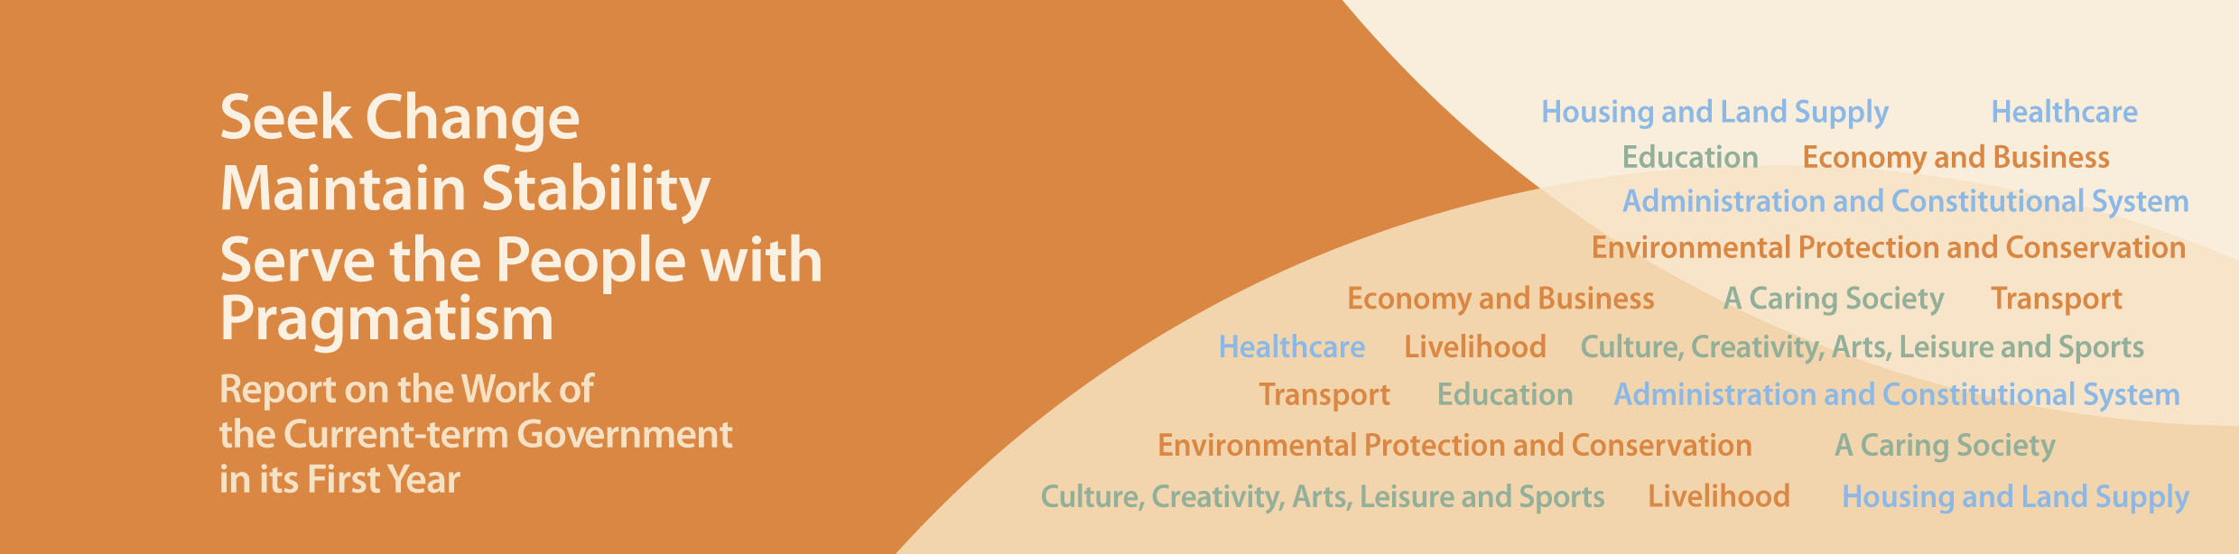
Environmental Protection and Conservation

- Published a Clean Air Plan in March 2013, which sets out various air quality improvement measures. These include setting joint targets with Guangdong Province for air pollutant emission reduction up to 2015 and 2020; implementing new Air Quality Objectives from 2014 onwards; phasing out heavily polluting pre-Euro IV diesel commercial vehicles with an earmarked allocation of $10 billion; and reducing emissions from marine vessels through mandating ocean-going vessels to switch to low-sulphur fuel when at berth in Hong Kong, upgrading the quality of local vessel fuel, and planning the installation of on-shore power facilities at the Kai Tak Cruise Terminal.
- Published the “Hong Kong: Blueprint for Sustainable Use of Resources 2013-2022” in May 2013, which sets out a comprehensive strategy, targets, policies and action plans for waste management for the coming 10 years in order to promote a “use less, waste less” culture.
- Launched the Energy Saving Charter on Indoor Temperature and the Energy Saving Charter on “No Incandescent Light Bulbs” in 2013 to encourage the community to save energy and adopt a low-carbon lifestyle.

