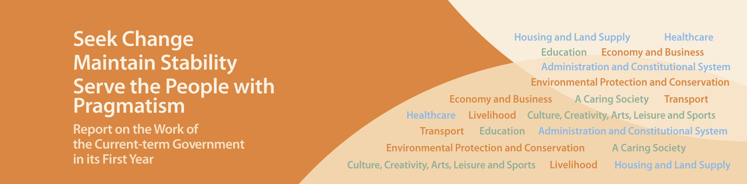
Education

- Set up a designated committee in April 2013 to study how to practicably implement free kindergarten education. This is a historic stride towards 15-year free education.
- Implemented a series of measures in Primary One Admission for 2013 to cope with the additional demand in North District arising from about 1,700 cross-boundary students. We will also study how to enhance the arrangements for the 2014-15 and subsequent school years so as to accord priority to students residing in Hong Kong in a lawful and reasonable manner.
- Implemented a basket of targeted relief measures with effect from the 2013-14 school year to help preserve our schools, the teaching force and the strengths of our education sector in face of the transient decline in Secondary One student population in the coming few years.
- Raised the ceiling of the Learning Support Grant for public sector primary and secondary schools by 50% to $1.5 million per school per year with effect from the 2013-14 school year.
- Revised the mode of support for schools for the 2013-14 school year by providing funding to all schools admitting 10 or more non-Chinese speaking (NCS) students so as to widen these students’ school choice and step up the support for NCS students’ mastery of Chinese Language and integration into the community. It is estimated to benefit about 100 schools.
- Allocated three vacant school premises in April 2013 for international school development in order to provide 1,700 school places by phases from the 2013-14 school year.

