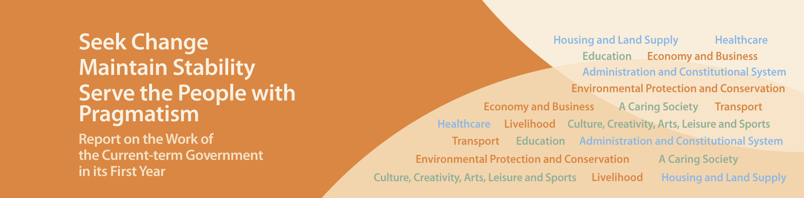
Healthcare

- Doubled the annual health care voucher amount for each eligible elder from $500 to $1,000 since January 2013. The Elderly Health Care Voucher Scheme will also become a recurrent programme from 2014.
- Implemented as a long-term policy the “zero delivery quota” arrangement to stop expectant Mainland mothers whose husbands are not Hong Kong residents (i.e. NEP2) from giving birth in Hong Kong. In 2013, all beds for obstetric services in public hospitals are reserved for local pregnant women and urgent cases referred by private hospitals. In the first five months of 2013, the average monthly delivery by NEP2 at Accident and Emergency Departments was only 17.6.
- Announced in August 2012 the intention to expedite legislative work relating to formula milk products and foods for infants and young children for health protection. Completed public consultation. Expect to introduce draft legislation in 2013-14 legislative session.
- To set up a committee soon to review the operation of the Hospital Authority. This is the first review of the Hospital Authority since its establishment 22 years ago.
- Established the Review Committee on Mental Health in May 2013 to review the mental health policy and map out the future direction for development of mental health services in Hong Kong.
- Disposed of the Wong Chuk Hang site through tender in March 2013 for developing a new private hospital with 500 beds to increase the overall capacity of the healthcare system. According to the lease conditions, the hospital will accord service priority to local residents and adopt a transparent fee-charging system, thereby providing the public with more choices for quality private hospital services.
- Established the Chinese Medicine Development Committee in February 2013 to discuss and study specific policy and measures relevant to a number of key areas, including personnel training and professional development, Chinese medicine services, scientific research and Chinese medicines industry development; and to give recommendations to the Government.
- Implemented comprehensive measures to prevent emerging global public health threats including the Middle East Respiratory Syndrome and Avian Influenza A (H7N9). These include enhancing surveillance and laboratory tests; liaison with other health authorities; port health measures; strictly implementing infection control measures; publicity and public education and drills. Hong Kong so far has not reported any case of infection.

