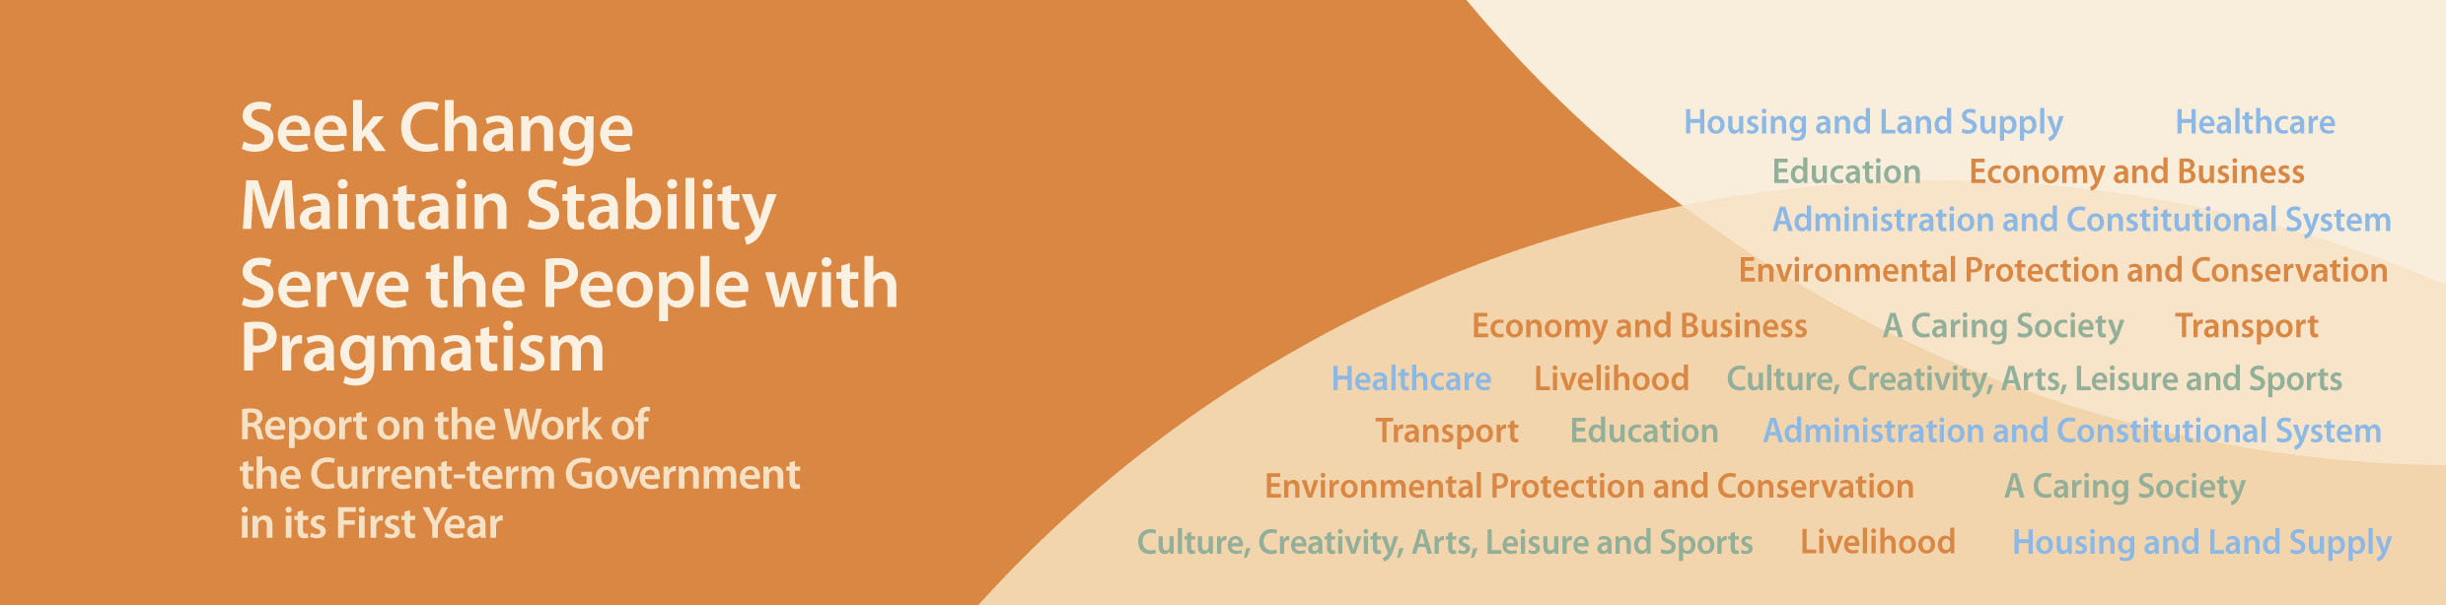
Transport

- The new Fare Adjustment Mechanism (FAM) for the MTR Corporation Limited which has been in effect since June 2013 will benefit passengers, as it adopts a new, objective and transparent methodology for calculating the Productivity Factor, and introduces a profit sharing mechanism, an affordability cap, a service performance arrangement, as well as new types of concessionary tickets.
- Co-ordinating various public transport services to tie in with the commissioning of five new railway lines in the coming seven years, with a view to fully leveraging on the environmental advantages of railways, enhancing the efficiency of the transport network and reducing air pollution.
- Announced in January 2013 that bus route rationalisation would be pursued more vigorously through an “area approach”, under which rationalisation would be considered having regard to the overall transport network and environmental benefits for a district/area. This will improve roadside air quality, ease traffic congestion and alleviate pressure for fare increases.
- Put forward three toll adjustment proposals in February 2013 as possible measures to improve traffic distribution among the road harbour crossings (RHCs), with a view to alleviating congestion at the Cross Harbour Tunnel and rationalising the traffic distribution among the RHCs. Completed public consultation. Expect to release the final proposal soon.

