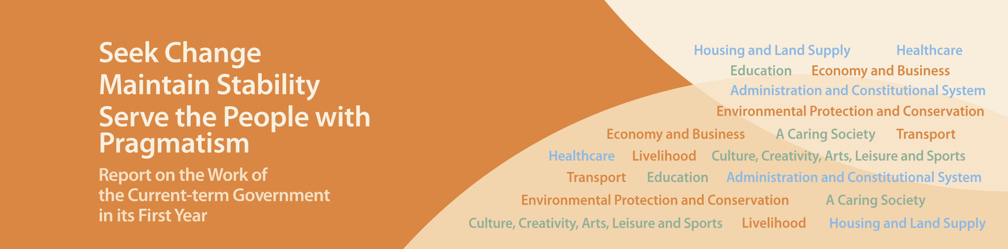
Culture, Creativity, Arts, Leisure and Sports

- Approved the Development Plan for the West Kowloon Cultural District in January 2013. The West Kowloon Cultural District Authority has selected the design teams for the Xiqu Centre and M+ Museum, and will commence the construction work as soon as possible.
- Injected an additional $300 million into the CreateSmart Initiative in May 2013 to provide sustained support for the development of creative industries.
- Aligned the fees and charges for sports and leisure facilities, municipal facilities and services in urban areas and the New Territories based on the lower of the current levels with effect from July and August 2013, benefiting about 7 million people annually.
- Allocated additional resources to support the Hong Kong Arts Development Council to provide about 10,000 square feet of art space for young artists in an industrial building in Wong Chuk Hang at a concessionary rent. Renovation works is expected to be completed in late 2013 or early 2014 for artists to move in.
- The Oil Street Artspace was partially opened in May 2013 and will be fully opened in September 2013, providing artists, particularly young artists, with a new venue for exhibitions and exchanges.
- Earmarked additional funding of $150 million to strengthen the training of arts administrators with different levels of experience for five years starting from 2013-14.
- Provided an additional $20.8 million a year for community involvement programmes from April 2013 to enhance the promotion of arts and culture by District Councils (DCs).
- Earmarked funding to implement the Pilot Scheme for Student Athlete Support in 2013-14 school year.
- Launched the First Feature Film Initiative in March 2013 to nurture talents for the local film industry by subsidising three new directors and their film production teams to make their first feature films on a commercial basis within two years. The estimated expenditure is $9.95 million.
- Provided annual funding of up to $4 million, $5 million and $5 million to each university designated as a local public research institution; Partner State Key Laboratory in Hong Kong, and Hong Kong Branch of Chinese National Engineering Research Centre(s) respectively for the three years starting from 2013-14. This will strengthen capabilities of research and development as well as technology transfer.
- Earmarked an additional $100 million in January 2013 for each district, i.e. $1.8 billion in total, for DCs to implement the Signature Project Scheme in the current term. Preliminary proposals submitted by DCs so far cover improvements to existing cultural or recreational facilities and enhancement of community health services, etc.

