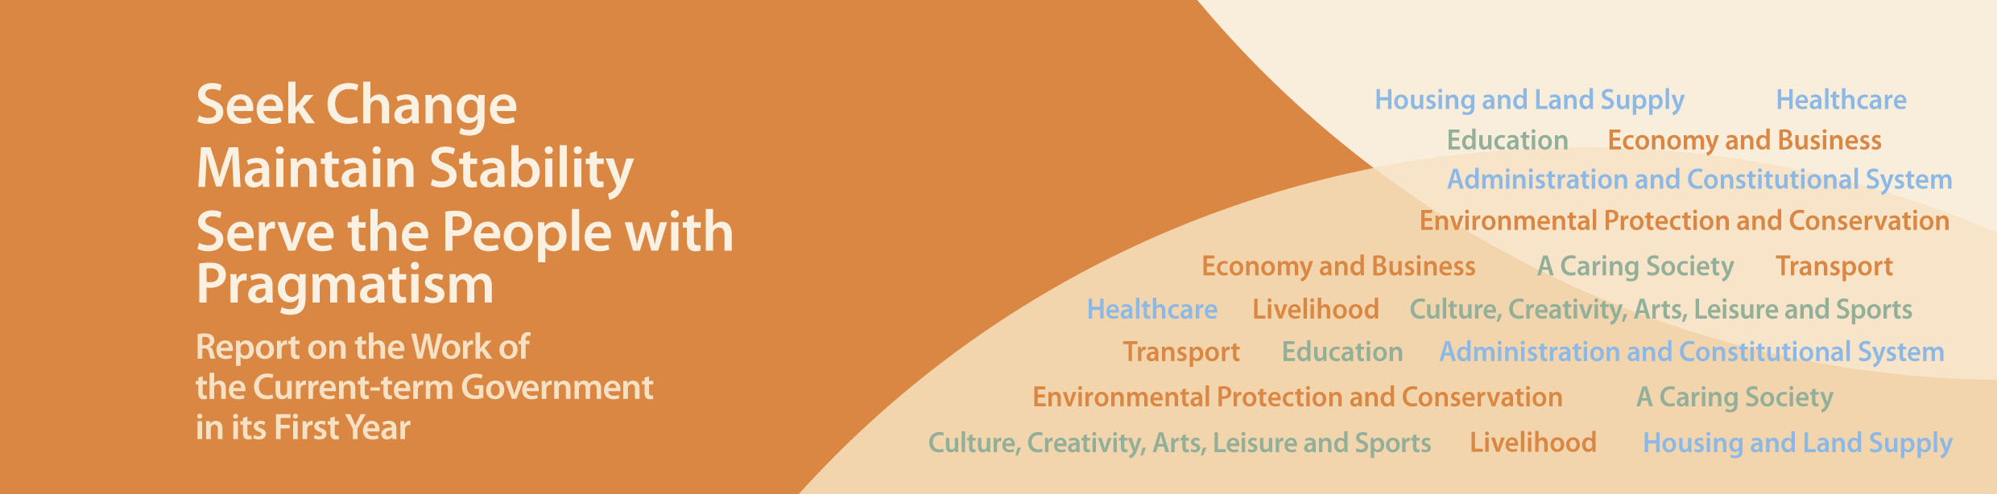
Administration and Constitutional System

- Held the LegCo election successfully in September 2012, and implemented the “one-person, two-votes” arrangement which further enhances the democratic elements of the LegCo election.
- Completed in May 2013 the legislative process to abolish all the DC appointed seats from the fifth-term DCs onwards.

