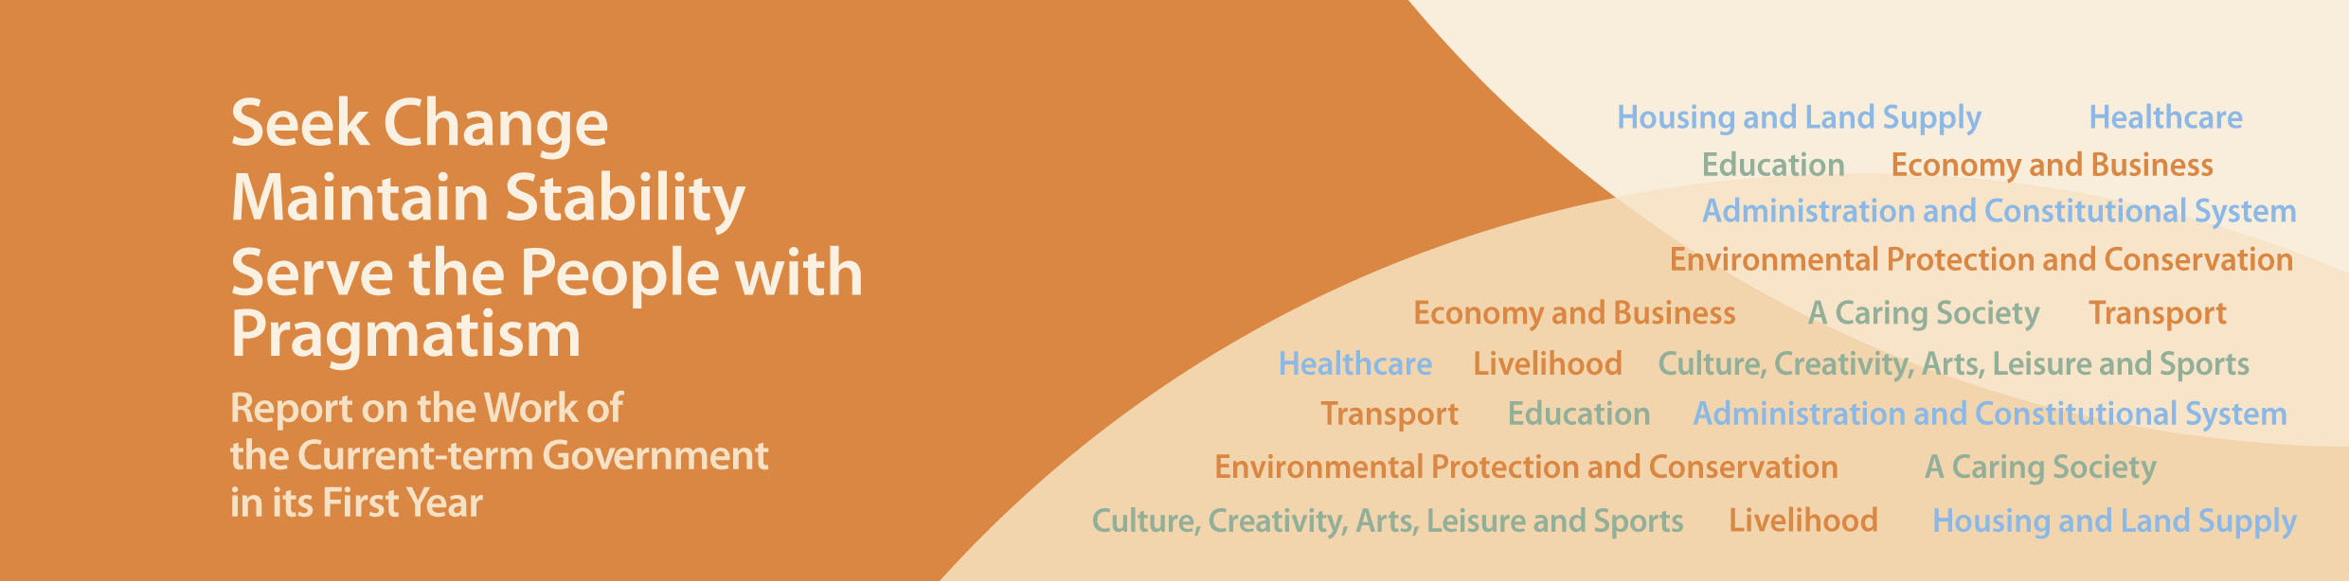
Foreword

Over the past year, with the support of civil servants, the political team of the fourth-term government and I have taken challenges head on and strived to address the needs and concerns of the people in a pragmatic way. We have resolved or effectively addressed several thorny issues in a short time, including the influx of pregnant Mainland mothers who rushed to accident and emergency wards for delivery; the short supply of baby formula; disruptions at train stations caused by parallel goods traders; admission to Primary One for cross-boundary students; multiple-entry permits to non-residents of Shenzhen; the threat of H7N9 influenza, etc. At the same time, we have made progress in delivering the pledges made in my election manifesto and my first Policy Address.

Over the past year, the HKSAR Government has clearly established the following key visions in administration: (1) resolve long-term social problems with economic development; (2) give priority to Hong Kong people on issues of scarce resources; (3) in view of the housing supply shortage, give priority to Hong Kong people, especially those acquiring properties for self-occupation; (4) manage Hong Kong’s political, economic and social relationships with both the Mainland and overseas; (5) make long-term planning for the future and discard short-sighted thinking; (6) take care of people in need and other disadvantaged groups; and, (7) attach great importance to communication with all walks of life in society.

The five key policy concerns clearly established by the Government – (1) economic development; (2) housing; (3) poverty; (4) ageing society; and (5) environmental protection – have received wide support from the community. Public consensus has also been forged on the policy principles of these five areas, namely: (1) the Government has a role to play in facilitating economic development; (2) the crux of the housing problem is inadequate supply and, thus, increasing land supply is the key to solving it; (3) the poverty problem has multiple causes and needs to be addressed through welfare, education and employment; (4) an ageing society poses unprecedented challenges which call for a feasible population policy and caring for the livelihood of the elderly; (5) the crux of environmental protection is to tackle the problems of air pollution and solid waste.

All seven million people in Hong Kong belong to one family. To keep Hong Kong growing and prospering, the Government and the whole community should share “one heart”. While we do face an array of challenges, there are even more opportunities. I believe that the fourth-term Government can make greater achievements during its tenure.

The achievements made by the SAR Government over the past year are listed below.

C Y Leung
Chief Executive

