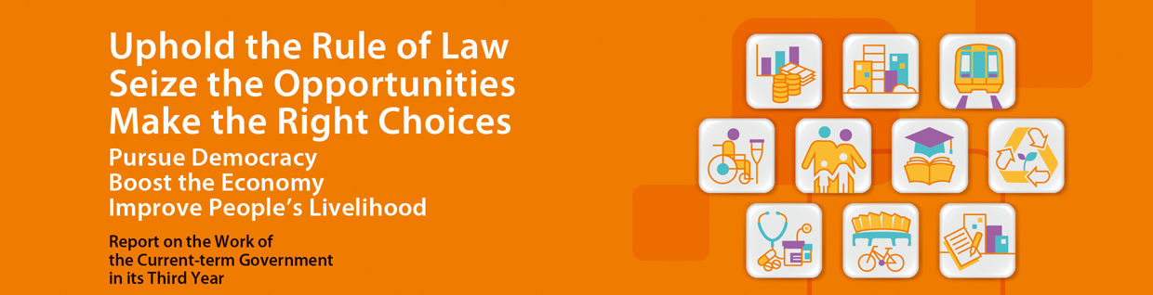
Youth Education and Development
- The Committee on Free Kindergarten Education submitted its report to the Government in May 2015 as scheduled, and made recommendations on the practicable provision of subsidized quality kindergarten education. The Government will study the proposals thoroughly and formulate policies and specific measures to improve the quality of kindergarten education and help children lay a solid foundation for future learning. Currently, over 140 000 children are studying in non-profit making local kindergartens and the new policies and measures are expected to benefit most of them.
- Based on the outcome of consultation, measures under the Fourth Strategy on Information Technology in Education have been refined and are scheduled for implementation from the 2015/16 school year onwards. The key measure is the phased provision of WiFi facilities in 1 000 public sector schools across the territory. Under the pilot scheme, WiFi infrastructure enhancement works at 100 schools were completed by January 2015 as scheduled, while works at the remaining 900 schools will be completed in 3 school years starting from 2015/16.
- Recommendations of the first two stages of the New Academic Structure Medium-term Review were announced in April 2014 and April 2015. They include introduction of additional classical set texts for the Chinese Language subject, cancellation of School-based Assessment for 7 subjects, updates to the curriculum content of different subjects and introduction of an additional level of performance for Applied Learning. The overall recommendations of the Medium-term Review will be announced in July 2015. Through a series of professional development programmes and provision of learning and teaching resources, school-based support, dissemination of good practices, etc., we will continue to enhance the professional capacity of teachers and school leaders to respond to social changes and to cater for students’ learning needs.
- Announced the establishment of the Multi-faceted Excellence Scholarship in the 2014 Policy Address. The Scholarship provides full sponsorship in the coming 5 years for universities and tertiary institutions to admit about 20 local students per year who have outstanding performance in sports, arts or community services. Candidates were selected in March 2015 and have been referred to the universities for consideration. The first batch of Scholars is expected to commence university studies in September 2015.
- The Committee on Professional Development of Teachers and Principals released its first progress report in April 2015. In addition to the Committee’s work progress and future plans, the report sets out the Committee’s views and recommendations on the professional development of teachers and principals at different career stages of professional growth, with a view to assisting them in preparing our younger generation for the new challenges of the 21st century. The Committee has commenced implementation of its recommendations.
- Subsequent to the allocation of 3 vacant school premises for international school development in April 2013, we have completed the allocation of 2 vacant school premises and 3 greenfield sites in the Southern District, Sai Kung and Tai Po to provide more international school places. A fresh round of consultancy study was commissioned in October 2014 to review the latest demand and supply of international school places. The study is expected to be completed by end-2015.
- The University of Chicago Booth School of Business started offering its flagship Executive Master of Business Administration (EMBA) programme at Cyberport in Hong Kong in August 2014. The School is expected to move into its new permanent campus at the ex-Victoria Road Detention Centre site at Mount Davis in 2018. The site was allocated to the School by the Government under the Land Grant Scheme.
- The Funding Scheme for Youth Life Planning Activities commenced operation in September 2014 and has granted over $25.6 million to 18 NGOs for organising, in collaboration with secondary schools, projects aiming at enhancing the knowledge and awareness of life planning and multiple pathways of students, parents and teachers. Most activities under that Scheme have been launched; it is expected that over 230 secondary schools (involving over 80 000 students, teachers and parents) will benefit from the Funding Scheme.
- Provided $1.36 million to the Hong Kong Federation of Youth Groups in 2014-15 for organising the “Promotion for Life Planning – Job-tionary” programme, so as to enhance promotion of life planning education and multiple pathways.
- Announced the establishment of a $300 million Youth Development Fund in the 2015 Policy Address. The Fund seeks to support innovative youth development activities not covered by existing schemes, and will provide financial support in the form of matching funds for NGOs to assist young people in starting their own business. We are consulting the Commission on Youth on the operational arrangements of the Fund. We plan to seek funding approval from the LegCo Finance Committee in 2015-16 legislative year.
- Building on the present experience in implementing various Mainland exchange programmes, more exchange opportunities will be provided for primary and secondary students from the 2015/16 school year onwards. This includes increasing the number of places for organising exchange programmes in alignment with curriculum, and encouraging schools to apply for subsidy to organize school-based Mainland exchange programmes. Our aim is to allow students to join at least one Mainland exchange programme each in the primary and secondary stages.
- Increased the provision for the Funding Scheme for Youth Internship in the Mainland to $54 million in 2015-16. About 3 000 young people are expected to benefit from the Scheme, representing an increase of about 100% over last year. The Scheme has also enhanced co-operation with the Guangdong Province for the first time to provide more internship places in Guangdong enterprises and government institutions, etc. for Hong Kong youth. Internship places will be offered in 5 cities, namely Guangzhou, Shenzhen, Dongguan, Foshan and Zhongshan.
- Increased the provision for the Funding Scheme for Youth Exchange in the Mainland to $30.9 million in 2015-16 to sponsor 199 exchange programmes. About 15 700 young people are expected to benefit, representing an increase of 43% over last year.
- Arranged for 10 university students from Hong Kong to take part in volunteer services of United Nations agencies per year, in collaboration with the United Nations Volunteers and local voluntary agencies. The first batch of volunteers will commence service in Southeast Asia in July 2015. We will also launch the “Guangdong- Hong Kong Youth Volunteers Programme”. Together with their Guangdong counterparts, tertiary students in Hong Kong will take part in a 7-day voluntary service programme in the rural areas of Guangdong Province during summer holiday this year. The volunteers will assist in teaching, cultural promotion, providing technical agricultural support, environmental protection education and providing medical services. The programme seeks to enhance mutual understanding and exchange between the youths in Hong Kong and Guangdong. Around 200 Hong Kong tertiary students are expected to join the programme this year.
- Provided $2.95 million for the International Youth Exchange Programme in 2015-16. About 140 young people are expected to benefit, representing an increase of 24% over last year.

