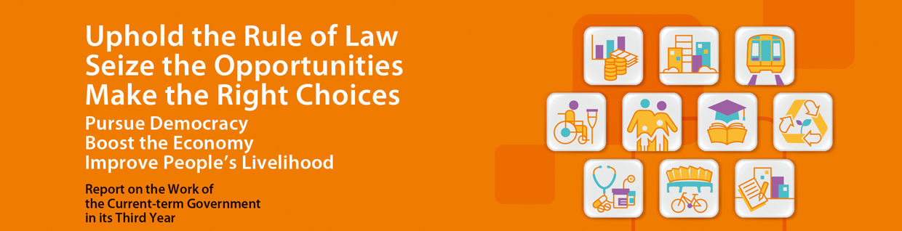
Environmental Protection and Conservation
- To improve roadside air quality and protecting public health, an incentive-cum-regulatory programme was rolled out in March 2014 to retire some 82 000 pre-Euro IV diesel commercial vehicles by end 2019. By the end of May 2015, some 28 200 vehicles have been retired, accounting for one-third of the target vehicles.
- Continued to progressively implement measures in the Clean Air Plan to improve air quality, including:
  - Enacting the Air Pollution Control (Ocean Going Vessels) (Fuel at Berth) Regulation to require ocean going vessels to switch to fuel with sulphur content not exceeding 0.5% while at berth, to reduce their emissions. The new regulation will come into force on 1 July 2015.
  - Enacting the Air Pollution Control (Non-road Mobile Machinery) (Emission) Regulation to control emissions from non-road mobile machinery such as generators and excavators. The new regulation commenced on 1 June 2015.
  - Extending the Cleaner Production Partnership Programme for five years until 2020 to continue encouraging Hong Kong-owned factories in both Hong Kong and Guangdong to adopt cleaner production technologies and practices, thereby improving regional air quality through enhancing energy efficiency and reducing emission of pollutants.
- Continued to progressively implement measures set out in the Hong Kong Blueprint for Sustainable Use of Resources, including:
  - Providing funding support to NGOs for recovery of surplus food and re-distribution to the needy through the Environment and Conservation Fund since July 2014.
  - The Council for Sustainable Development submitted its report on the public engagement on municipal solid waste charging to the Government in December 2014. The Government reported to the LegCo on the framework proposal for implementing charging, and commenced preparatory work for taking forward the recommendations in February 2015.
  - Awarding the Design-Build-Operate contract for Phase 1 of the Organic Waste Treatment Facilities (OWTF) in December 2014. The OWTF Phase 1 will have the capacity to turn 200 tonnes of source separated food waste into useful resources per day upon its commissioning in mid-2017.
  - The Sludge Treatment Facility commenced operation in April 2015. The Facility will progressively replace the disposal of sludge by landfilling and generate energy from waste.
  - Full implementation of the Plastic Shopping Bag Charging to cover the entire retail sector in April 2015.
  - The Waste Electrical and Electronic Equipment (WEEE) Treatment and Recycling Facility commenced construction in May 2015, and will support the future Producer Responsibility Scheme on WEEE.
  - Developing the Community Green Stations (CGS) in each of the 18 districts, which will be operated by non-profit making organisations to promote environmental education and help collect different types of recyclables at the district level. The first facility under the initiative, namely the Sha Tin CGS, opened doors to the public in May 2015.
- On energy:
  - Completed the works for Phases I and II of the District Cooling System (DCS) at the Kai Tak Development in January 2013 and September 2014 respectively. The DCS Ordinance, which stipulates the charging level, was passed by the LegCo in March 2015. Provision of district cooling services to the Kai Tak Cruise Terminal building and Ching Long Shopping Centre commenced in February 2013 and May 2013 respectively.
  - Consulted the public between March and June 2015 on the future development of the electricity market after the current Scheme of Control Agreements with the 2 power companies expire in 2018.
  - Unveiled the first-ever energy saving blueprint for Hong Kong in May 2015. The blueprint sets for Hong Kong a new target of reducing energy intensity by 40% by 2025. The “Energy Saving for All” Campaign was also launched to promote territory-wide energy saving.
- Completed the main works of the Harbour Area Treatment Scheme Stage 2A in January 2015. Upon its full commissioning by end-2015, the water quality of the main body of Victoria Harbour will further improve.
- The Task Force on External Lighting completed its study and submitted its report to the Government in April 2015. The Task Force recommended a multi-pronged approach to address the issues of light nuisance and energy wastage caused by external lighting. The Government will launch charter and award schemes in 2015, and organise public education and publicity programmes. The Guidelines on Industry Best Practices for External Lighting Installations will also be re-launched.
- Established task forces from March 2015 to follow up on the Antiquities Advisory Board’s recommendations on the conservation of built heritage. Recommendations included the setting up of a dedicated fund on the conservation of built heritage to support restoration, maintenance and revitalisation of historic buildings, and to provide funding for public education and publicity activities, and academic research etc.
- Announced the selection result for Batch IV of the Revitalising Historic Buildings Through Partnership Scheme in mid-June 2015. Batch IV projects include No. 12 School Street, Old Dairy Farm Senior Staff Quarters, Lady Ho Tung Welfare Centre and King Yin Lei. Among these 4 historic buildings, the Government will continue to manage King Yin Lei and open it for public enjoyment. The Stone Houses and Old Tai Po Police Station under Batch II of the Scheme were soft-opened in the second quarter of 2015.
- Declared the Lin Fa Temple in Tai Hang, Hung Shing Temple in Ap Lei Chau and Hau Wong Temple in Kowloon City as monuments in October 2014.

