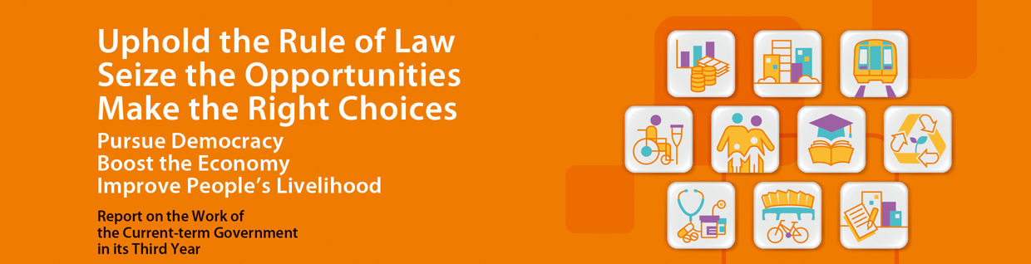
Constitutional Development and District Administration
- Submitted a report to the Standing Committee of the National People’s Congress (NPCSC) in July 2014 to invite the NPCSC to make a determination on whether there is a need to amend the methods for selecting the Chief Executive in 2017 and for forming the LegCo in 2016. This formally kick-started the “Five-step Process” of constitutional development. In August 2014, the NPCSC adopted a decision that universal suffrage for the Chief Executive election could be implemented starting from 2017.
- Launched the second round consultation on the method for selecting the Chief Executive in January 2015.
- Published the Consultation Report and Proposals on the Method for Selecting the Chief Executive by Universal Suffrage in April 2015, and on 2 June 2015, put forward to the LegCo a motion to amend the method for the selection of the Chief Executive. The motion was vetoed on 18 June 2015. The method for selecting the 4th term Chief Executive in 2012 will be adopted to select the 5th term Chief Executive in 2017.
- Consulted the LegCo Panel on Home Affairs in February 2015 on the proposals to increase the honorarium of DC members by 15% in real terms and offer every DC member a new provision of $10,000 per term to cover duty visit expenses with effect from the 5th term DC (2016-2019). The funding application will be submitted to LegCo Finance Committee within 2015 for consideration.
- Provided an additional annual dedicated funding of $20.8 million for community involvement programmes from 2015-16 to 2019-20 to further strengthen the support for DCs in promoting arts and cultural activities in the districts.
- Successfully conducted the Rural Ordinary Election in January 2015 under the supervision of the Electoral Affairs Commission. In particular, the Kaifong Representative Election was held under a legal framework for the first time.
- HKSARG attaches great importance to the relationship between the Executive and the Legislature. The Basic Law has endowed different powers and responsibilities to the two authorities. In the current LegCo session, thus far the LegCo has passed 16 bills covering a range of policy areas and about 110 subsidiary legislation proposals or amendments put forward by the Government.
- Some LegCo Members filibustered on the Appropriation Bills for 3 consecutive years, causing a waste of time to the Legislature and hindering government operation, to the detriment of Hong Kong. The public at large is tired of the “non-co-operation movement” of some Members at the Finance Committee. Passage of the 2015 Appropriation Bill was delayed to end-May this year. To maintain core public services, the Government implemented contingency measures in mid-May by re-deploying remaining funds under the Vote-on-Account and deferring subvention payment for June in respect of the HA, LegCo Commission and the tertiary educational institutions funded by the University Grants Committee. Owing to the slow progress in the examination of items by the Finance Committee in the last legislative session, 27 public works items had been deferred for 6 months on average and the total project cost had increased by $2.5 billion.
- HKSARG looks forward to working hand in hand with the LegCo for the social and economic betterment of Hong Kong. On 19 June 2015, the Government proactively announced that 11 economic and livelihood items would be submitted to the LegCo Finance Committee, prior to submission of the proposals for the establishment of the Innovation and Technology Bureau.

