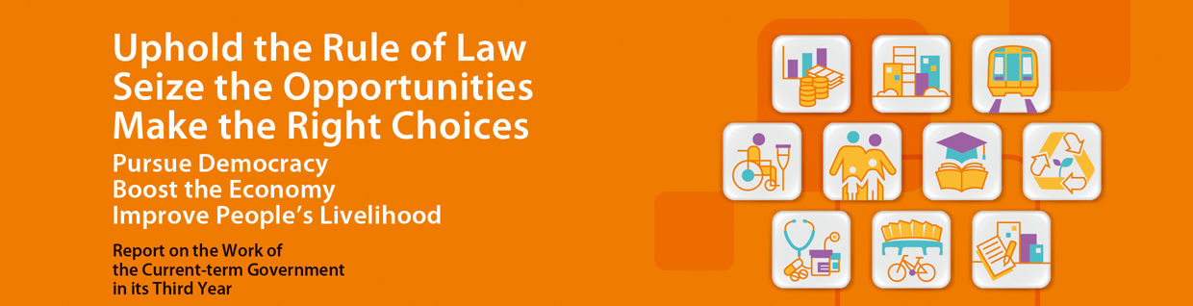
Foreword
In the third year, the current-term Government continues to make solid progress in its work. This is my third Report to the people of Hong Kong.

The three major missions of the current-term Government are developing the economy, improving people’s livelihood and promoting democracy. On the economy, the HKSAR Government is making relentless efforts to strengthen the established industries, assist the emerging industries and diversify the economic base. In the past year, the Shanghai-Hong Kong Stock Connect was launched, and Hong Kong agreed with the Mainland to implement the mutual recognition of funds. Guangdong Province has implemented the basic liberalisation of trade in services with Hong Kong. We have also decided to build a third runway for our airport. All these are major initiatives to boost the economy now and for the future. In the past year, the economy was generally performing well, and the Government recorded a handsome fiscal surplus that could be ploughed back to society.

On the livelihood front, the Government has announced the Long Term Housing Strategy last year, and has continued to increase housing land supply by multiple means. The increased land supply after the current-term Government assumed office is turning into notably larger housing production. The completions of private domestic units next year is estimated to be a record high for 10 years, and is higher than the average annual production of the past 10 years by about 70%, addressing the serious shortage that has built up over a long time. Our efforts on poverty alleviation are also beginning to show results, with a smaller number of people living below the poverty line. Government Public Transport Fare Concession Scheme has been extended to green minibuses by phases. The Government is also taking a series of measures to handle the challenges posed by the aging population and shrinking workforce.

Opportunities abound for the economy of Hong Kong, and we must seize them. Hong Kong is also facing a host of challenges, and the community must come together in response. After finishing the work on the method of selecting the Chief Executive in 2017, the HKSAR Government will concentrate on addressing the issues of the economy and people’s livelihood, and continue to increase housing supply and step up alleviating poverty. We will build a firmer basis for the economy and society of Hong Kong to prosper.

I am grateful for the support of the political team, civil servants and society at large for their support in the past year, and I look forward to working together with all in Hong Kong in the forthcoming year for a brighter future.

C Y Leung
Chief Executive

