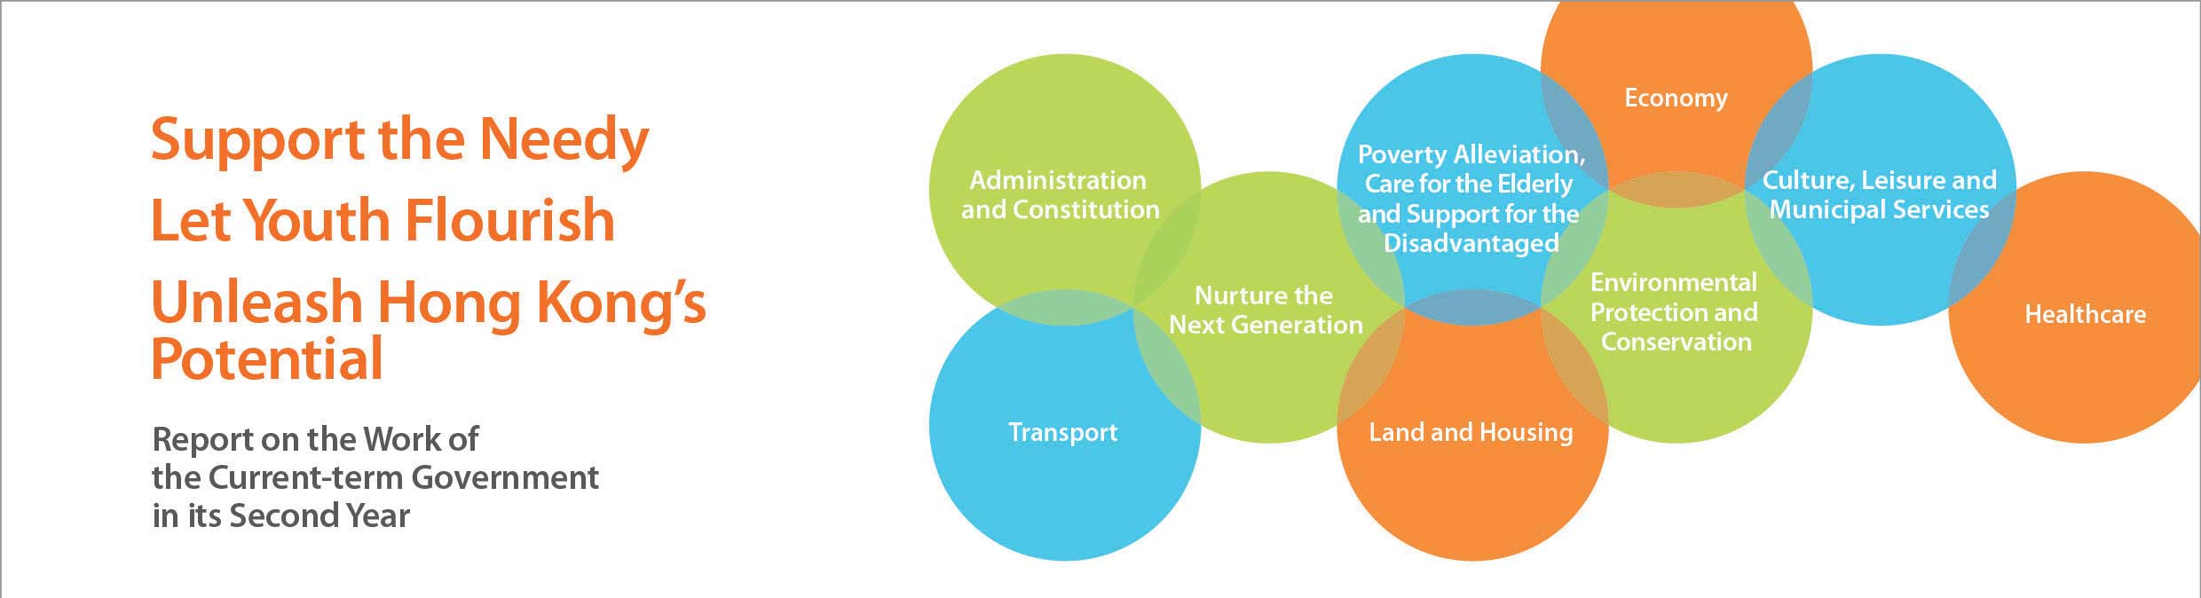
Nurture the Next Generation
• The participation rate of the relevant age cohort in undergraduate programmes reached 38% in the 2013-14 academic year. Including sub-degree courses, nearly 70% of young people would have access to post-secondary education.
• Announced in January 2014 to further increase subsidised higher education opportunities. Measures included:
––Increasing the annual intake of senior year subsidised undergraduate places by 1 000. By the 2018-19 academic year, 5 000 meritorious sub-degree graduates could articulate to subsidised degree places each year.
  - ––Launching a new scholarship scheme to support up to 100 outstanding Hong Kong students per cohort to study in renowned universities outside Hong Kong. We propose that the scheme would benefit three cohorts of students and then be subject to a review on its effectiveness.
  - ––Exploring how to practically introduce a new subsidy scheme to subsidise up to 1 000 students per cohort to pursue designated full-time locally-accredited self-financing undergraduate programmes in selected disciplines to nurture talent to meet Hong Kong’s social and economic needs. We propose that the scheme would benefit three cohorts of students and then be subject to a review on its effectiveness.
  - ––Launching a Mainland University Study Subsidy Scheme to support needy students pursuing studies under the Scheme for Admission of Hong Kong Students to Mainland Higher Education Institutions. We propose that the scheme would benefit three cohorts of students and then be subject to a review on its effectiveness.
  - ––Establishing a “Multi-faceted Excellence Scholarship” to subsidise, on a full cost-recovery basis, universities and tertiary institutions to admit annually a total of about 20 local students who excel in sports, arts and/or community service to study undergraduate courses.
• Announced in January 2014 enhanced assistance to young people in relation to life planning and vocational education to further facilitate young people’s transition from study to work. Measures included:
––Setting up a Task Force on Vocational Education to map out a strategy to promote vocational education in the community, and inviting the Vocational Training Council (VTC) to draw up a strategic development plan to enhance the image and quality of vocational education.
  - ––Launching a pilot scheme at the VTC to integrate vocational education and employment support for industries with a keen demand for labour. Trainees would receive a grant/allowance, while participating industries would undertake to offer employment after training and provide clear career progression pathways.
  - ––Providing the VTC with recurrent funding to provide industrial attachment for all higher diploma and some diploma students. Over 9 000 students would benefit per annum.
  - ––Establishing a $1 billion fund to provide long-term support to the development of the Qualifications Framework to enhance the quality of the workforce.
  - ––Allocating additional resources to schools and NGOs to enhance career guidance services for secondary students, and promote the concept of multiple pathways. More business establishments and community resources would be encouraged to take part in the Business-School Partnership Programme. From the 2014-15 school year, each government, aided and Direct Subsidy Scheme school operating classes at senior secondary levels would be provided with a recurrent cash grant of about $0.5 million per annum adjusted annually thereafter.
• Launched the two-year New Academic Structure Medium-term Review in October 2013 to further optimise the arrangement of the senior secondary curriculum and assessment, and announced the first batch of recommendations in April 2014. The last batch of recommendations would be announced by mid July 2015.
• Launched a consultation on the Fourth Strategy on Information Technology in Education in May 2014. Suggested actions included, amongst others, the setting up of wireless networks in all government and aided schools by phases. Provision of wireless networks for 100 schools would be completed by August 2014, and for the remaining schools starting from the 2015-16 school year, by phases.
• Revised the arrangements under the Central Allocation stage of the Primary One Admission System for cross-boundary students from the 2014-15 school year. A designated Choice of Schools List has been compiled with a view to relieving the pressure on North District by providing these students with school choices in other districts. The revised arrangements aim to cater for the needs of local students while ensuring that cross-boundary students would be provided with government and aided Primary One places.
• Increased the voucher subsidy of the Pre-primary Education Voucher Scheme (PEVS) on a one-off basis in the 2014-15 and 2015-16 school years. The voucher subsidy would be increased by $2,500 per year, and the fee remission ceiling would be lifted to the 75th percentile of the school fees of the respective kindergartens under the PEVS. The increase aims to alleviate the pressure of kindergartens in meeting increased operating costs and relieve the financial burden of parents. In the 2014-15 school year, about 80% of kindergarten students (i.e. around 139 000 students) would benefit from the measures.
• Doubled the recurrent subvention for uniformed groups such as the Scout Association, the Hong Kong Red Cross and the Hong Kong Road Safety Patrol from 2014-15, and increased funding for the Assistance Scheme for Needy Student Members. The two measures are expected to benefit 138 500 and 14 000 members respectively.
• Allocated $19 million to the Commission on Youth’s new Funding Scheme for Youth Internship in the Mainland in 2014-15 to support 38 Mainland internship programmes which would benefit 1 700 youths – an increase of 160%.
• Increased the allocation to the Commission on Youth’s Community Participation Scheme for Organising Exchange Tours to the Mainland by $3.9 million to $20.9 million in 2014-15, so as to subsidise 135 exchange programmes which would benefit 11 000 youths – an increase of a 15%.
• Increased funding for the International Youth Exchange Programme by nearly 100% to $2.95 million in 2014-15. The Programme currently covers Ireland, Singapore and Japan, and would be expanded to cover Poland as well. Meanwhile, discussions with Russia are progressing well.
• Injected $15 billion into the Employees Retraining Board in February 2014 to finance its services and operation on a long-term basis.

