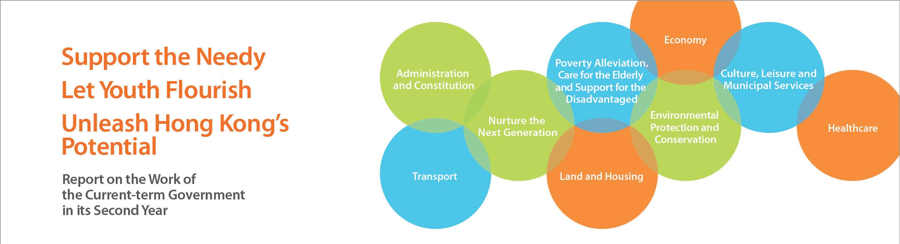
Transport
• Commenced a systemic reform of the Marine Department in May 2013. The reform encompasses a comprehensive review of legislation and measures on the regulation of passenger safety and local vessels, business processes and operational procedures of the Department, as well as the Department’s manpower strategy and training matters. In November 2013, as the first phase of improvement measures, the Code of Practice for local vessels was amended to introduce five measures to enhance the safety of local vessels.
• Finalised the “Railway Development Strategy 2014” blueprint to provide a planning framework for the future expansion of Hong Kong’s railway network, having regard to the overall recommendations of the consultant. The blueprint is expected to be announced later in 2014.
• Continued to co-ordinate various public transport services to tie in with the completion of five railway lines in the coming six years, with a view to fully leveraging the environmental advantages of railways and further enhance the transport network efficiency.
• Completed the bus route rationalisation exercise in the North District and Tuen Mun in the first quarter of 2014 under an Area Approach. This exercise, together with the regular annual rationalisation of franchised bus routes, helps improve the efficiency of the bus network, reduce roadside air pollution, and alleviate traffic congestion and pressure to increase fare.
• In March 2014, the Transport Advisory Committee was invited to conduct a study on containing road traffic congestion in Hong Kong, with a view to proposing to the Government short- and medium-term improvement measures at a territorial level by end-2014.
• Continued to closely supervise the Airport Authority Hong Kong in taking forward the planning work for the Three-Runway System project. With the completion of the Environmental Impact Assessment for the project, the relevant planning work is expected to be completed within 2014.
• Urged the MTR Corporation Limited (MTRCL) to conduct a thorough investigation into serious service disruption incidents and to take proper follow-up actions to maintain the safety and reliability of the railway service. The MTRCL was also invited to enhance train frequency, purchase new trains, upgrade its signalling system and launch the “Early Bird Discount Promotion” Trial Programme to relieve crowding in train compartments during peak hours.
• Announced in May 2014 the establishment of an Independent Expert Panel to conduct a thorough examination of the project management and cost control mechanism and practices of the MTRCL regarding the Hong Kong section of the Guangzhou-Shenzhen-Hong Kong Express Rail Link, as well as the existing project supervision mechanism adopted by the Government. The objective is to identify problems and the reasons behind them, as well as to make recommendations on improvement. The review is expected to be completed by end-November 2014.
• Commenced the construction of the connecting road of the Liantang/Heung Yuen Wai Boundary Control Point in phases starting from July 2013 to tie in with the commissioning of the Boundary Control Point in 2018.
• Completed the two-stage public consultation on the provision of an elevated rail-based environmentally friendly linkage system supporting the development of the core business district in Kowloon East in February 2014. Preparatory work is being carried out for the detailed feasibility study.

