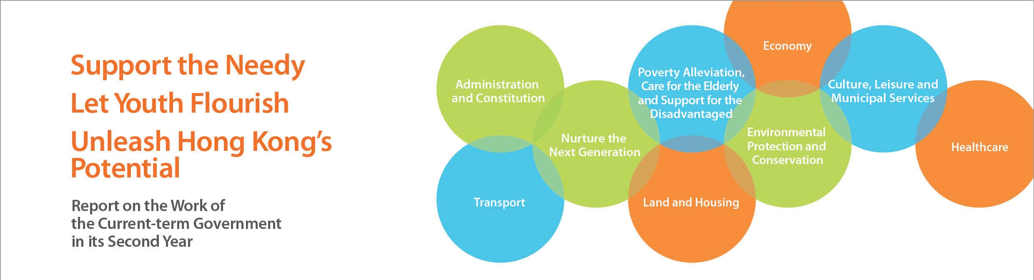
Environmental Protection and Conservation
• Continued to progressively implement the Clean Air Plan to improve air quality, including:
––Launching the Air Quality Health Index on 30 December 2013, and implementing the new Air Quality Objectives on 1 January 2014.
  - ––Launching a regulatory-cum-incentive scheme in March 2014 to progressively retire some 82 000 pre-Euro IV diesel commercial vehicles. The subsidy amounts to $11.4 billion.
  - ––Introducing a new regulation in April 2014 to reduce the sulphur content of marine light diesel supplied to local vessels by 90%.
• Continued to progressively implement measures set out in the Hong Kong Blueprint for Sustainable Use of Resources, including:
––Completing the public engagement exercise on the Municipal Solid Waste charging scheme in January 2014. In April 2014, the Government announced the launch of a six-month pilot scheme to help solicit experience and feedback towards the scheme. The Environmental Levy Scheme on Plastics Shopping Bag would also be extended to the entire retail sector starting from April 2015.
  - ––Announcing in January 2014 that $1 billion would be earmarked to set up a Recycling Fund to promote the sustainable development of the recycling industry.
  - ––Promulgating “A Food Waste & Yard Waste Plan for Hong Kong 2014 - 2022” in February 2014. For the first time, the Government has analysed comprehensively the current situation of food waste and yard waste in Hong Kong, and proposes reduction at source, reuse and donation, recyclable collection, and turning food waste into energy as the four main directions to tackle the food waste challenge.
  - ––Commissioning the Sludge Treatment Facility which is expected to come into operation by end-2014. The Facility will progressively replace the current disposal of sludge by landfilling and generate energy from waste.
  - ––Announcing in January 2014 the establishment of a Restored Landfill Revitalisation Funding Scheme with earmarked funding of $1 billion. The Scheme aims to subsidise the development of recreational facilities or other innovative uses at restored landfills. The Subsidy Scheme for Retrofitting Refuse Collection Vehicles (RCVs) has also been introduced and the retrofitting of all private RCVs with a fully enclosed design is aimed to be completed within 2014-15, so as to address the odour problem of RCVs effectively.
• The Antiquities Advisory Board (AAB) launched a two-month public consultation in June 2014 to assist the Government to review the policy on conservation of privately-owned historic buildings.
• Launched Batch IV of the Revitalising Historic Buildings Through Partnership Scheme (Revitalisation Scheme) in December 2013 to invite proposals from non-profit-making organisations for the adaptive re-use of No.12 School Street, the Old Dairy Farm Senior Staff Quarters, Lady Ho Tung Welfare Centre and King Yin Lei. The Mei Ho House Youth Hostel under Batch I of the Revitalisation Scheme commenced operation since October 2013, while the Jao Tsung-I Academy and the PMQ were opened in June 2014.
• Declared the Béthanie in Pok Fu Lam, Cenotaph in Central, Tat Tak Communal Hall in Ping Shan and Fat Tat Tong in Ha Wo Hang as monuments in November and December 2013.

