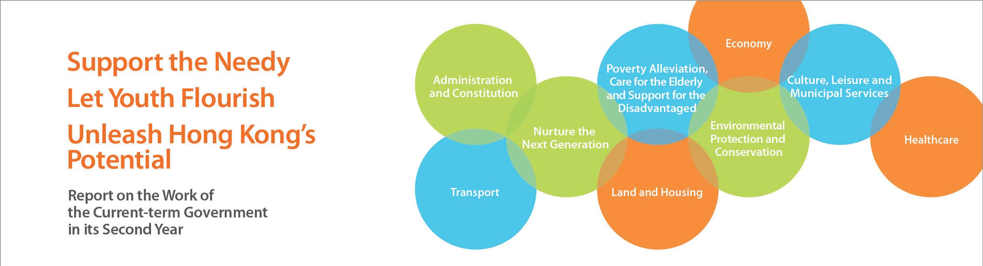
Healthcare
• Set up a Review Steering Committee in August 2013 to conduct an overall review of the operation of the HA, with a view to ensuring that the HA would remain capable of responding to challenges arising from changes in society and an ageing population. The target is to complete the review in early 2015.
• Accepted the recommendation of the Chinese Medicine Development Committee in January 2014 to reserve a site in Tseung Kwan O, which was originally earmarked for private hospital development, for the development of a Chinese medicine hospital. Besides, to help gather experience in the operation and regulation of the integrated Chinese-Western medicine (ICWM) and Chinese medicine in-patient service, the HA planned to implement in the third quarter of 2014 a two-year ICWM pilot project to provide HA patients of selected disease areas with ICWM in-patient treatment and follow-up Chinese medicine out-patient service.
• Introduced the Electronic Health Record Sharing System Bill in April 2014 to establish a legal framework that would enable public and private healthcare providers to share patients’ medical records with patients’ consent. The new system would enhance public-private partnership in the healthcare sector.
• Regularised the Elderly Health Care Voucher Scheme from January 2014, and increased the annual voucher value for each eligible elder from $1000 to $2000 starting from June 2014.
• Launched a four-year Pilot Project on Dental Service for Patients with Intellectual Disability in August 2013 in collaboration with the Hong Kong Dental Association, the Hong Kong Special Care Dentistry Association and the Evangel Hospital, whereby subsidised dental service supplemented with special support measures would be provided to eligible persons with moderate intellectual disability. The Government has set aside $20 million for the Pilot Project, and expects that some 1 600 persons would benefit.
• Allocated about $420 million in the five-year period from 2014-15 to the Department of Health to develop and implement, in collaboration with the HA, a pilot programme to subsidise persons in specific age groups to receive colorectal cancer screening.

