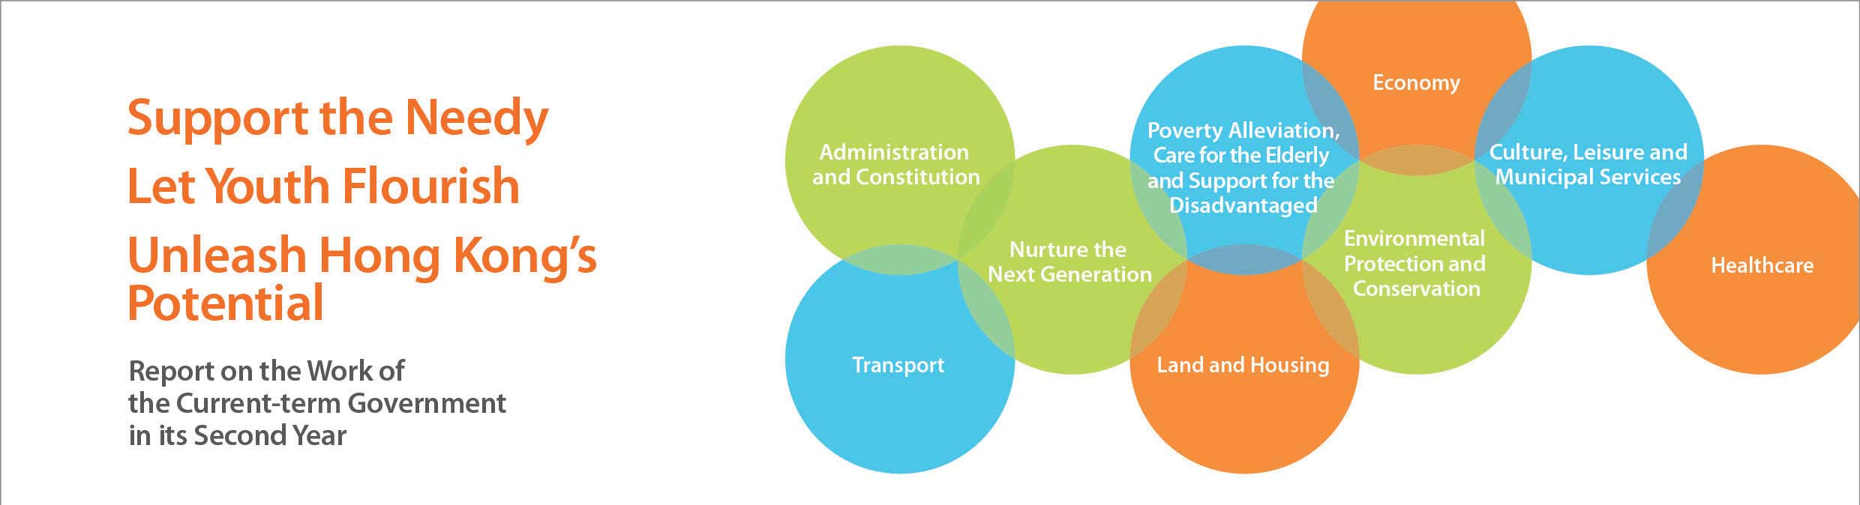
Culture, Leisure and Municipal Services
• The PMQ, the revitalised Former Police Married Quarters on Hollywood Road, opened in June 2014. It provides studios for over 100 creative establishments as well as activity venues for creative industries.
• Various new sports venues came into operation in the past year, including the new Victoria Park Swimming Pool Complex in September 2013; the Hong Kong Velodrome (our first cycling track built to international standards), and other sports facilities there, opened in phases from January 2014; and part of the Kai Tak Runway Park Phase 1 in April 2014.
• Completed the consultancy on the financing and procurement options for the Multi-Purpose Sports Complex at Kai Tak at end-2013, and decided that the Complex should be funded under the Public Works Project model.
• Aligned the fees and charges for most public sports and leisure facilities, as well as recreational and sports programmes provided by the Leisure and Cultural Services Department (LCSD), by adopting the lower of the prevailing current levels, with effect from August and October 2013.
• Hong Kong athletes took part in a number of major events in 2013, including the Asian Youth Games in Nanjing, the National Games in Shenyang and the East Asian Games in Tianjin. They achieved outstanding results, winning a total of 83 medals: 13 gold, 24 silver and 46 bronze medals for these three events alone.
• Increased financial support for First Division district football teams from $0.55 million to $1 million per season in 2013. Three district football teams are now qualified and interested in participating in the Hong Kong Premier League, which would begin in the 2014-15 season.
• Launched the Pilot Scheme for Student Athlete Support in the 2013-14 school year to provide support for students from low-income families to realise their sporting potential, in collaboration with the Hong Kong School Sports Federation. A total of 363 schools participated in the Scheme in its first year.
• The Hong Kong Sports Institute completed a consultancy study on direct financial support for elite athletes. The Institute is also working with a number of schools to provide a more conducive environment for young athletes to balance their education needs and training.
• Increased recurrent funding for the Hong Kong Arts Development Council by about $30 million to $120 million from 2014-15 onwards to strengthen support for small and medium size art groups and artists. The recurrent subvention for the nine major performing arts groups was also increased by about $30 million to $334.6 million, to enhance support for the groups’ work in promoting the development of performing arts in Hong Kong.
• The West Kowloon Cultural District Authority commenced construction works for the Xiqu Centre in September 2013. The Authority has also commenced design work for the M+ Museum, the Arts Pavilion, the Park and Lyric Theatre. The Government is actively supporting the work of the Authority to facilitate the early implementation of various facilities in the District.
• Announced in January 2014 the Hong Kong Museum of Art expansion and renovation project. It is expected that gallery space would increase by more than 40%.
• Held a number of major exhibitions in 2013, including the “Splendours of Royal Costume: Qing Court Attire” which was jointly organised with the Palace Museum and the “Legends of the Giant Dinosaurs”. LCSD museums saw a record number of 6.13 million visitors in 2013, an increase of about 6% over 2012 and a growth of 36% since 2010. The “Legends of the Giant Dinosaurs” exhibition attracted more than 770 000 visitors, breaking all attendance records for exhibitions held at public museums. These exhibitions have successfully built up a wider audience base and helped raise public interest in arts, history and science.
• Completed the first territory-wide survey of intangible cultural heritage (ICH) in Hong Kong and promulgated the first ICH inventory of Hong Kong in June 2014.
• Commenced operation of the new Multimedia Information System for public libraries in August 2013 to provide readers with a more convenient and efficient way to search and use library digital collections and multimedia information. In early 2014, the System was extended to cover over 1 200 workstations at 67 libraries and became accessible to the public via the internet or mobile devices anytime and anywhere. In March 2014, the revamped library portal was launched to further facilitate use by the public.
• Launched a $230 million five-year assistance scheme in June 2013 to help 4 300 hawkers enhance the fire safety standards and design of their hawker stalls. As of June 2014, enhancement measures have been agreed with the relevant stakeholders in relation to about 60% of about 500 cases identified as carrying higher fire risks. Reconstruction of the stalls in various hawker areas (such as Li Yuen Street East and Li Yuen Street West in Central) is being completed progressively, in accordance with the new fire safety requirements.
• Commissioned a consultant in December 2013 to develop proposals to improve the operating environment of public markets, so that the markets could fulfil their functions in a manner consistent with their positioning to serve the public. The consultant would put up preliminary proposals in the third quarter of 2014.

