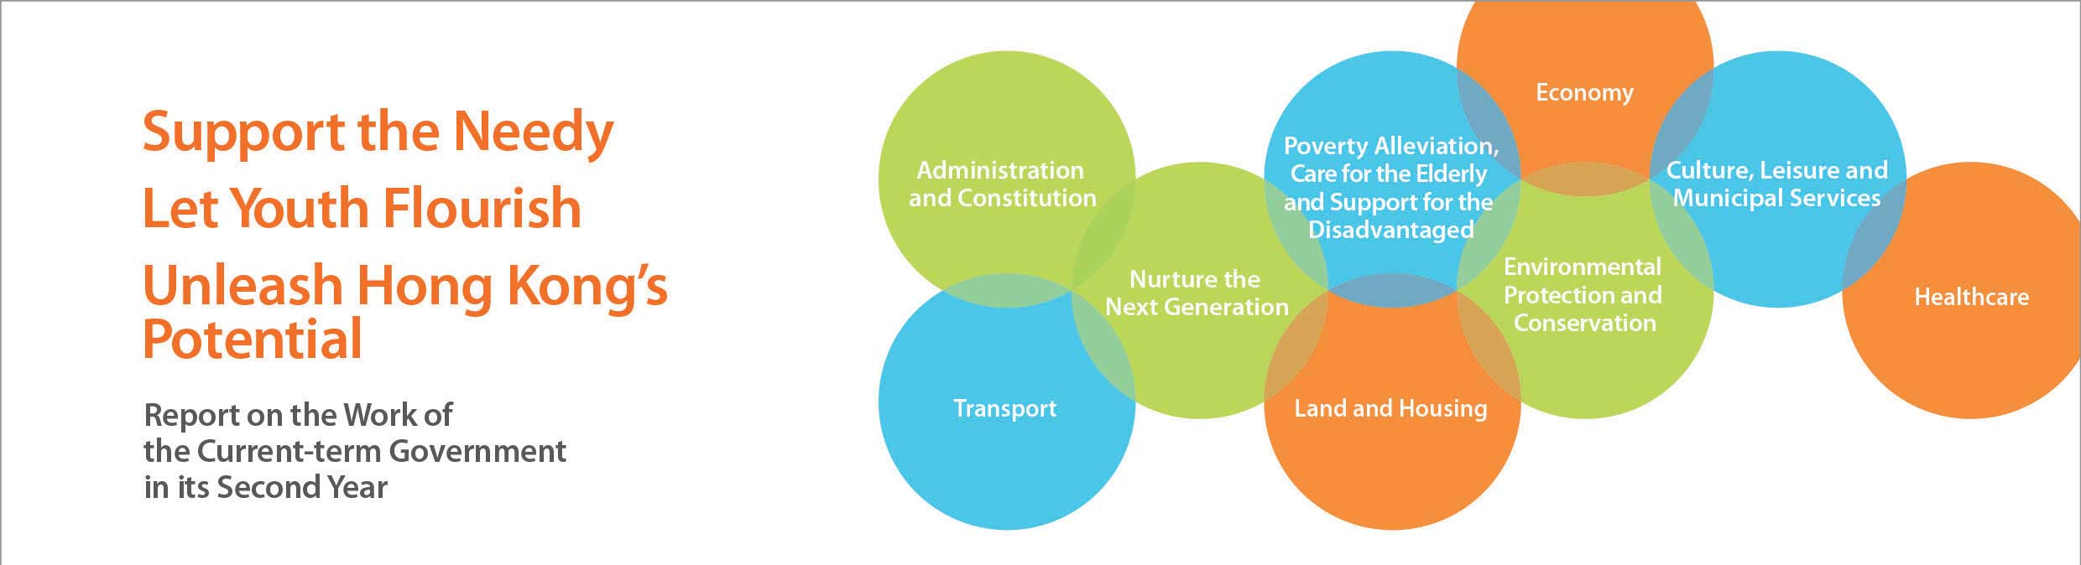
Administration and Constitution
• Established the Task Force on Constitutional Development in October 2013, and launched in December 2013 a five-month public consultation on the methods for selecting the Chief Executive in 2017 and for forming the Legislative Council in 2016 to prepare for the “Five-step Process” of constitutional development.
• Launched a four-month consultation on proposals to extend the service of civil servants in April 2014, with a view to drawing up suitable measures to enable the Government to better respond to the challenges arising from an ageing population and to provide departments with flexible human resource tools to address operational and succession needs at different times.
• Completed the legislative process to increase the number of DC elected seats by 19 to 431, starting from the fifth-term DCs commencing 2016.
• The Rural Representative Election Amendment Ordinance was passed in March 2014, a step forward in implementing the improvement measures arising from the review on rural elections.
• Introduced a pilot scheme in Sham Shui Po and Yuen Long in April 2014, which provided the District Management Committees chaired by District Officers with the decision-making power to tackle the management and environmental hygiene problems of some public areas, and with advice from DCs on the work priorities. The pilot scheme aims to take forward the concept of “addressing district issues at the local level and capitalising on local opportunities”. The Government provided each district with a one-off provision of $5 million and additional manpower to implement the pilot scheme.
• Increased the expense reimbursements for DC members with effect from January 2014, including an increase of 34% in real terms in the Operating Expenses Reimbursement.
• Organised the Summit on District Administration in October and November 2013 for the Government, DCs and district personalities to exchange views and discuss issues of district concern. The Summit report is due to be published at end-June 2014.

