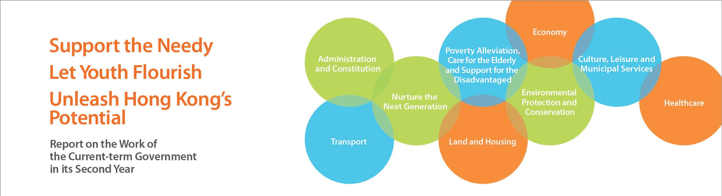
Foreword
Last year, I uploaded onto the Internet the Report on the Work of the Current-term Government in its First Year, highlighting our work and achievements. Similarly, this year’s report outlines the progress made by the current-term Government on various fronts in its second year.
The current-term Government is committed to promoting economic development, improving people’s livelihood, and taking forward constitutional development for more effective governance. We seek change while maintaining stability, adopt an appropriately proactive approach, attach importance to long-term planning and have abandoned the mindset of focusing on short-term needs. We hope that all Hongkongers will enjoy the opportunity to realise their potential and live out their aspirations.
Over the past two years, the Government has worked hard to sustain our economic growth and to address many of Hong Kong’s deep-seated problems. We have achieved significant progress on a number of important issues. For example, we are doing our utmost to increase land and housing supply in the short, medium and long terms. We have implemented measures to effectively manage demand and curb rising property prices. The Government has set our first-ever official poverty line and has consulted the public and canvassed views on important issues affecting Hong Kong’s future development such as the long-term housing strategy and population policy, as well as the methods for selecting the Chief Executive in 2017 and for forming the Legislative Council in 2016.
Our policy initiatives this year are focused on assisting low-income working families, the elderly and the underprivileged, and providing the younger generation with better education and training opportunities to help them seize opportunities and overcome challenges. At the same time, we are committed to further enhancing our economic development, and improving the environment and quality of life.
Supported by, and working in tandem with, the political team and our huge team of dedicated civil servants, the current-term Government will continue to build a better Hong Kong together with the whole community with one heart and one vision.

C Y Leung Chief Executive

